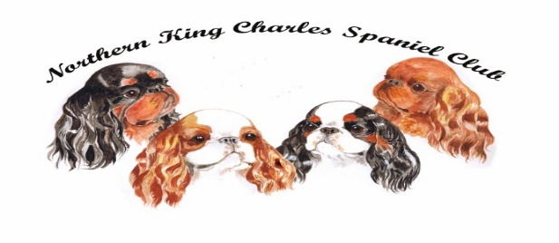
2022 YEARBOOK ADVERTISEMENT ORDER FORM
COVID lockdown has been a tough time for us all with no shows and breeding plans put on hold.
So for this yearbook only, the Northern wants to give back.
We invite you to book advertisements in the yearbook at special
** LOCKDOWN-KNOCK-DOWN PRICES!! **
Only £20 for your first colour page and all subsequent pages just £5 per page.
Special rate for PET OWNERS (who do not show their dogs) of £5 per page.
Your name: |  |  |  | Your affix:
Your postal address: |  |  |  | Telephone:
Your email:
Please note this issue will be ready for CRUFTS 2022 |  |  |  |  | Number required
One full colour page with text and colour photograph/s |  |  |  | £20
All subsequent pages |  |  |  | £5
Pet pages |  |  |  | £5
Please return/email this completed form to JOHN GOODWIN to book your space by 15 SEPTEMBER 2021
All copy, photos and payment must be received if possible by 30 NOVEMBER 2021
By direct bank payment to: Sort Code 40-19-15 | a/c no: 02049686
Overseas Members: direct bank payments: please contact the Treasurer for the IBAN

Or send a cheque to the Treasurer, ADRIAN TONNER, payable to The Northern King Charles Spaniel Club

You can ONLY submit photographs as follows:
- As a high resolution (minimum 300 pixels per inch JPEG photo
- Within a finished PDF advert (see below right)
Text can be provided separately in a WORD doc format. Adverts with larger photos and less text have more impact. Keep text to an absolute minimum and make sure it will fit onto an A5 page and still be readable when printed.

Original photos for scanning cannot be accepted
If you do not have pre-designed artwork, you can send your text in an email or WORD attachment with your JPEG photos and John will design your ad for you. Proofs will be emailed prior to publication.

Hard copy adverts that need to be re-typed will not be accepted.

Help and information  Stephen Smith (Chair)  Tel: 01332 663579  Justacharma@hotmail.co.uk |  | Booking forms, advert copy and any design requests  John Goodwin  Tel: 07584 494987  (please leave a  message or text)  diggledogs@yahoo.co.uk | PDFs  For anyone wanting to submit finished artwork (PDF) the page size is A5 PORTRAIT  Do not compose on A4 or the text may not fit the page  or be too small to read  Good photos say much more than lots of text!  YOU MUST LEAVE AT LEAST 1CM AROUND THE EDGE CLEAR OF ANY TEXT OR PHOTOS OR THEY MAY BLEED OFF THE PAGE WHEN PRINTED

